1. Create a stored procedure that displays employees hired in the last ‘n’ years.

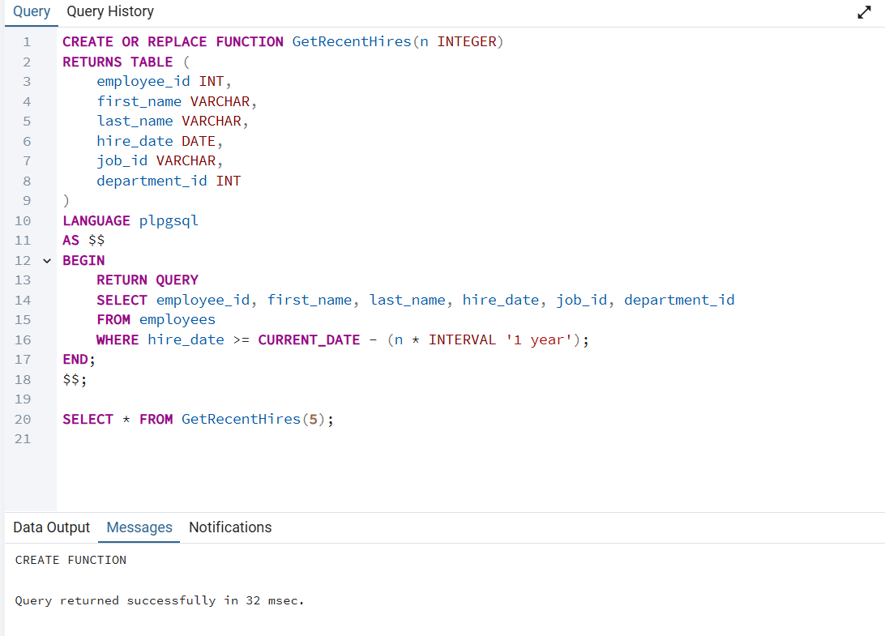

2. Each employee has a **hire date** recorded in the database. The procedure will check if

today's date matches the **anniversary of the employee's hire date**, and if it does, it will

log the event or trigger an action like congratulating the employee.

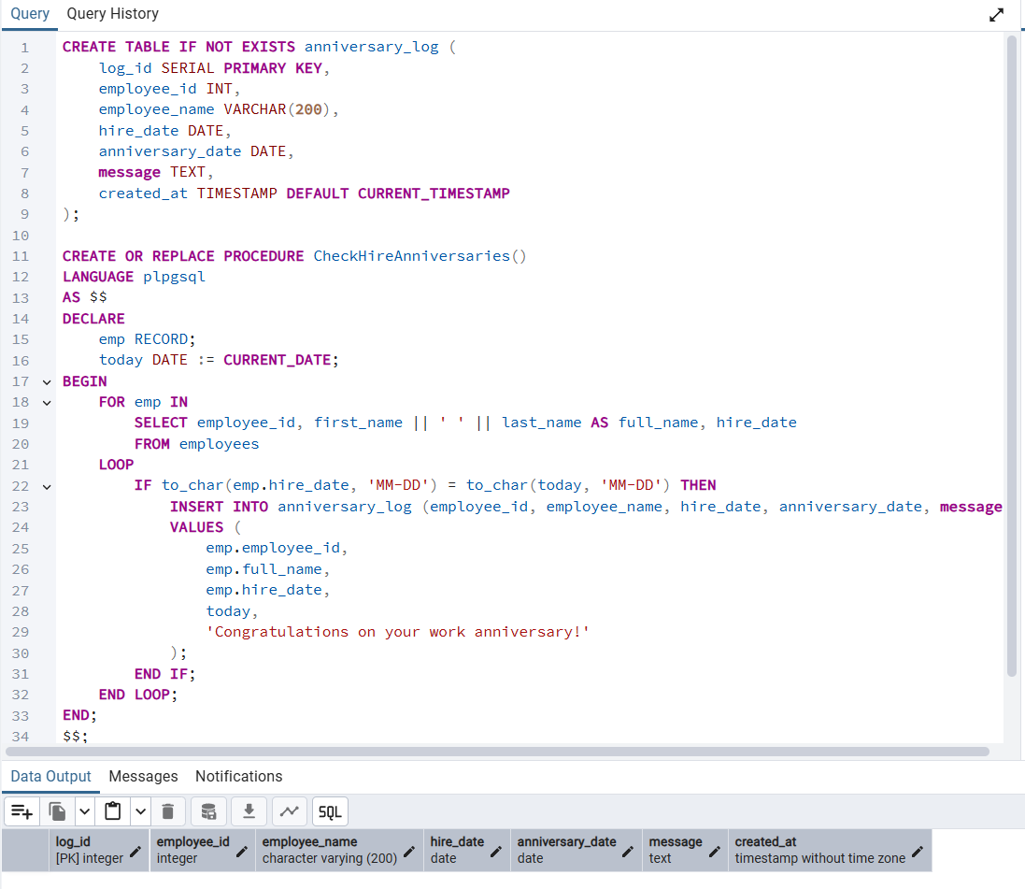

3.Create a stored procedure named CalculatePayroll() that adjusts the salaries of

employees based on their job role. The procedure should use a CASE statement to apply

different salary increases depending on the job title, and it should handle salary updates

in a loop for all employees. The salary adjustments are as follows:

**IT_PROG**: 10% increase

**HR_REP**: 5% increase

**SA_REP**: 7% increase

**Other roles**: 3% increase

Additionally, the procedure should implement error handling, ensuring that the process

continues even if no more records are found. After calculating the new salary for each

employee, the procedure should update the employee's salary in the database and log

the payroll calculation in a payroll_log table with the employee's ID, new salary, and

calculation date.

